SECUREFILEX: BLOCKCHAIN-BASED FILE
SHARING SYSTEM


Submitted by:
Muhammad Irfan
AUP-20FL-BSCS-17908
Fatir Ali
AUP-20FL-BSCS-17954
Submitted by:
Dr. Fahad Masood

A final year project report submitted in partial fulfillment of the requirement for the award of Bachelor of Science in Computer Science

Department of Computing
Abasyn University Peshawar

May 2024
APPROVAL FOR SUBMISSION
This is certified that this project report entitled “SecureFileX: Blockchain-based File Sharing System” is developed and submitted by Muhammad Irfan, Fatir Ali registration number 17908, 17954 meets the required standards for warrant its acceptance by the department of computing, Abasyn University Peshawar in partial fulfilment for the award of Bachelor of Science in Computer Science
Approval Committee:

Supervisor | Name | Dr. Fahad Masood
 | Designation | Assistant Professor
 | Institute | Abasyn University, Peshawar
 | Signature

External Examiner | Name
 | Designation
 | Institute
 | Signature

Internal Examiner | Name
 | Designation
 | Institute
 | Signature

Head of Department:
Name | Dr. Syed Irfan Ullah
Signature

DECLARATION OF ORGINALITY

We hereby declare that this project report entitles as “SecureFileX: Blockchain-based File Sharing System” is based on our original work except for citations and quotations which have been duly acknowledged. We also declare that it has not been previously and concurrently submitted for any other degree or award at Abasyn University Peshawar or any other institutions.
We hereby undertake that if any part of this work is proved to be copied or found to be a part of some other work, the Abasyn University Peshawar reserves the right to withdraw/revoke our degree.

________________
Muhammad Irfan

________________
Fatir Ali

DEDICATION
We would like to extend our deepest gratitude to our supervisor, Dr. Fahad Masood, Assistant Professor, for his unwavering support, insightful guidance, and constant encouragement throughout the course of our thesis. His expertise and dedication have been instrumental in shaping this thesis, and his constructive feedback has significantly enriched my work. Dr. Fahad Masood’s commitment to fostering an environment of academic excellence and his willingness to always go the extra mile have been truly inspirational. This work would not have been possible without his invaluable mentorship, and we are profoundly grateful for the opportunity to learn from him.

ACKNOWLEDGEMENTS

We would like to thank everyone who had contributed to the successful completion of this project. We would like to express our gratitude to our project supervisor, Dr. Fahad Masood for his invaluable advice, guidance and his enormous patience throughout the development and completion of this project.

In addition, we would also like to express our gratitude to our loving parent and friends who had helped and given us encouragement.

ABSTRACT

In the digital age, data security and accessibility have become paramount concerns as the exchange of information continues to grow exponentially. The "SecureFileX: Blockchain-based File Sharing System" project addresses these concerns by leveraging blockchain technology to revolutionize the way we share and manage files. This project aims to create a secure, transparent, and decentralized platform that overcomes the limitations of traditional file sharing systems, which often suffer from centralized control, data security issues, and user privacy risks. Traditional file sharing platforms are vulnerable to breaches and unauthorized access due to their reliance on centralized servers, which can be single points of failure. The need for a comprehensive, tamper-proof environment has never been more urgent. SecureFileX addresses these vulnerabilities by implementing blockchain technology, which ensures secure and transparent transactions. Blockchain’s inherent properties, such as decentralization, immutability, and cryptographic security, provide a robust foundation for a next-generation file sharing system. SecureFileX utilizes smart contracts and decentralized storage solutions to enhance security and user control. Smart contracts automate and enforce the terms of file sharing agreements, reducing the need for intermediaries and minimizing the risk of human error or fraud. Additionally, decentralized storage solutions like the Interplanetary File System (IPFS) distribute data across multiple nodes, enhancing data availability and resilience while reducing the risk of data loss or unauthorized access.

TABLE OF CONTENTS

APPROVAL FOR SUBMISSION ii
DECLARATION OF ORIGINALITY iii
DEDICATION iv
ACKNOWLEDGMENTS v
ABSTRACT vi
LIST OF TABLES …vii
LIST OF FIGURES viii
ACRONYMS xi

CHAPTER TITLE PAGE
1 INTRODUCTION
1.1 Background 1
1.2 Problem Statement 2
1.3 Aims and Objectives 3
1.3.1 Aims 3
1.3.2 Objectives 3
1.4 Scope and Limitation 4
1.4.1 Scope 4
1.4.2 Limitations 5
1.5 Project Significance 5
1.6 Expected Output 6
1.7 Utilization of Project 6

2 LITERATURE REVIEW
2.1 Introduction 7
2.2 Traditional File Sharing Systems 7
2.2.1 Centralized Control 7
2.2.2 Data Security 8
2.2.3 User Privacy 8
2.3 Blockchain Technology: An overview 8
2.3.1 Decentralization 9
2.3.2 Security 9
2.3.3 Transparency and Immutability 9
2.4 Blockchain in Data Security and File Sharing 10
2.4.1 Enhanced Security Mechanisms 10
2.4.2 Privacy Preservation 11
2.5 Existing Blockchain-based File Sharing Solutions 11
2.5.1 Storj 11
2.5.2 Filecoin 11
2.5.3 Sia 12
2.6 Challenges and Limitations 12
2.6.1 Scalability 12
2.6.2 Cost 12
2.7 Future Directions 13
3 RESEARCH METHODOLOGY
3.1 Introduction 14
3.1.1 Planning 14
3.1.2 Design 14
3.1.3 Implementation 14
3.1.4 Testing 14
3.1.5 Deployment 15
3.2 Project Requirements 15
3.3 Project Schedule and Milestones 15
3.4 Requirement Analysis 16
3.5 Functional Requirements 16
3.6 Non-Functional Requirement 17
4 ANALYSES
4.1 Header Design 18
4.2 Footer Design 18
4.3 Dashboard 18
4.4 Login 19
4.5 Sign Up 19
4.6 Upload 20
4.7 Update User 20
4.8 Side Bar 21
4.9 Buy 22
4.10 Marketplace 22
4.11 Premium Plan 23
5 ARCHITECTURE AND DESIGN
5.1 Introduction 24
5.2 System Overview 25
5.2.1 User Interface 25
5.2.2 Backend Infrastructure 25
5.2.3 Blockchain Network 25
5.2.4 Decentralized Storage 25
5.3 Blockchain Architecture 25
5.4 File Storage and Management 26
5.5 Context Diagram 26
5.6 Entity Relationship Diagram {ERD} 27
5.7 Level 0 DFD 28
5.8 Level 1 DFD 28
5.9 Level 2 DFD 29
5.10 System Workflow 29
5.11 Scalability and Performance Considerations 30
5.12 Integration with Existing Systems 30
6 IMPLEMENTATIONS
6.1 Frontend Implementation 31
6.1.1 Frameworks and Libraries 31
6.1.2 React.js 31
6.1.3 Next.js 31
6.1.4 HTML2Canvas 31
6.1.5 jsPDF 32
6.1.6 Code Structure 32
6.1.7 Components 32
6.1.8 Pages 32
6.1.9 Styles 33
6.2 Key Features 33
6.2.1 User Authentication 33
6.2.2 Dynamic Content 33
6.2.3 PDF Generation 33
6.3 Backend Implementation 33
6.3.1 Frameworks and Libraries 33
6.3.2 Node.js 33
6.3.3 bcryptjs 34
6.3.4 axios 34
6.3.5 ethers.js 34
6.4 Code Structure 34
6.4.1 Controllers 34
6.4.2 Routes 34
6.4.3 Models 34
6.4.4 API Endpoints 35
6.4.5 Blockchain Interaction 35
6.4.6 Data Management 35
6.5 Blockchain Implementation 35
6.5.1 Solidity 35
6.5.2 Web3Modal 35
6.5.3 Key features 35
6.6 Storage Implementation 36
6.6.1 IPFS 36
6.6.2 Pinata 36
6.6.3 File Upload 36
6.6.4 File Retrieval 36
6.7 Build and Deployment 36
6.8 Programming Languages 36
7 TESTING AND EVALUATION
7.1 Introduction 37
7.2.1 Unit Testing 37
7.2.2 Integration Testing 37
7.2.3 System Testing 38
7.2.4 Process of Test Plan 38
7.2.5 Acceptance Testing 38
7.3 Testing Introduction 39
7.4 Implications for Data Governance 39
7.5 Integration with Existing Systems 39
7.6 User Experience Design 40
8 CONCLUSIONS
8.1 Recapitulation of Objectives 41
8.2 Achievements and Milestones 41
8.3 Impact and Implications 41
8.4 Future Directions 41
8.5 Gratitude and Acknowledgments 41
REFERENCE 42

LIST OF TABLES

Table 7.1 Unit Testing 37
Table 7.2 Integration Testing 38
Table 7.3 System Testing 38
Table 7.4 Acceptance Testing 39
Table 7.5 Testing Introduction 39

LIST OF FIGURES
Figure 4.1 Header Design 17
Figure 4.2 Footer Design 17
Figure 4.3 Dashboard 18
Figure 4.4 Login 19
Figure 4.5 Sign Up 19
Figure 4.6 Upload 20
Figure 4.7 Update User 20
Figure 4.8 Side Bar 21
Figure 4.9 Buy 22
Figure 4.10 Marketplace 23
Figure 4.11 Premium Plan 23
Figure 5.1 Context Diagram 26
Figure 5.2 Entity Relationship Diagram {ERD} 27
Figure 5.3 Level 0 DFD 28
Figure 5.4 Level 1 DFD 29
Figure 5.5 Level 2 DFD 29

CHAPTER 1

INTRODUCTION

Introduction
Data security and accessibility have become increasingly important in the digital age, where information is being exchanged at an unprecedented pace. Our project, SecureFileX: Blockchain-based File Sharing System, finds its purpose within this evolving landscape. The proliferation of sensitive digital assets, combined with the need for transparent and decentralized data management, has created a demand for innovative solutions to address these challenges. SecureFileX aims to meet this demand by leveraging blockchain technology to provide a secure, transparent, and decentralized environment for file sharing.[1]
In contemporary digital ecosystems, various platforms are continuously sharing data. However, existing file sharing systems often suffer from significant issues related to centralized control, data security, and user privacy. Traditional solutions are typically built on centralized architectures, which present multiple risks and limitations. Centralized control means that data is stored on central servers managed by a single entity, making it a prime target for hackers. This centralized approach also creates single points of failure, where a breach or failure at the central server can lead to widespread data loss or unauthorized access. Moreover, user privacy is often compromised in traditional file sharing systems. These systems usually require users to trust the central authority with their data, which might not always uphold the highest standards of security or privacy. Unauthorized access and data breaches are common issues, as these systems do not provide a comprehensive, tamper-proof environment for data management. Users are often left vulnerable to potential privacy invasions, data manipulation, and unauthorized access.[1]
To address these shortcomings, our project employs blockchain technology, a paradigm that promises secure and transparent transactions. Blockchain technology, initially popularized by cryptocurrencies like Bitcoin, is increasingly being recognized for its potential to revolutionize various sectors, including file sharing. A blockchain is essentially a distributed ledger that records transactions across multiple computers in such a way that the registered transactions cannot be altered retroactively. This ensures that once data is added to the blockchain, it is immutable and tamper-proof. The decentralized nature of blockchain technology eliminates the need for a central authority, thereby reducing the risks associated with centralized control. In a blockchain-based file sharing system, data is not stored on a single server but is distributed across a network of nodes. Each node maintains a copy of the entire blockchain, ensuring that the system is resilient to attacks and failures. This decentralized approach enhances data security and ensures that there is no single point of failure. Furthermore, blockchain technology enhances transparency and trust. Each transaction on the blockchain is recorded in a public ledger that is accessible to all participants in the network. This transparency ensures that all actions are visible and verifiable, reducing the chances of fraud and unauthorized access. Users can trust the system because they do not need to rely on a central authority; instead, they rely on the cryptographic principles underpinning the blockchain.
SecureFileX aims to harness these benefits of blockchain technology to create a file sharing system that prioritizes security, privacy, and transparency. By doing so, it addresses the inherent weaknesses of traditional file sharing systems and provides a robust solution for the secure exchange of digital assets. This innovative approach not only enhances data security but also empowers users by giving them greater control over their data.

1.2 Problem Statement
In the modern digital landscape, the exchange of information is ubiquitous and essential for various personal, professional, and organizational activities. However, the prevalent file sharing systems are plagued by critical issues that undermine data security, user privacy, and the integrity of shared information. These issues are primarily rooted in the centralized nature of traditional file sharing architectures, which pose several risks and limitations. One of the main problems with centralized file sharing systems is the susceptibility to data breaches and unauthorized access. Centralized systems rely on central servers to store and manage data, making them attractive targets for cyberattacks. Hackers can exploit vulnerabilities in these servers to gain unauthorized access to sensitive information, leading to data breaches that can have severe consequences for individuals and organizations. The centralized control also means that if the central server is compromised, the entire system is at risk, leading to potential data loss or manipulation.[2]
Another significant issue is the lack of user privacy. Traditional file sharing systems often require users to trust the central authority with their data, which might not always uphold stringent security and privacy standards. This trust-based model exposes users to risks of privacy invasion, as the central authority has complete control over the data and can potentially misuse it. Additionally, the lack of transparency in how data is managed and accessed in these systems further exacerbates privacy concerns. Furthermore, the centralized nature of traditional file sharing systems creates single points of failure. If the central server experiences downtime or technical issues, the entire file sharing system can become unavailable, disrupting the flow of information and causing inconvenience to users.

1.3 Aims and Objectives

1.3.1 Aims:
The primary aim of SecureFileX: Blockchain-based File Sharing System is to develop a secure, transparent, and decentralized platform for sharing digital files. This project seeks to address the inherent weaknesses of traditional file sharing systems by leveraging the robust and immutable nature of blockchain technology.[2]

Objectives:
The objective is to ensure that shared files are protected against unauthorized access, data breaches, and tampering. This objective will be achieved by implementing robust encryption protocols, multi-factor authentication, and advanced security measures.
- Ensure User Privacy:
The goal is to provide a system where users have full control over their data without the need to trust central authority. This will be accomplished by incorporating decentralized identity management and end-to-end encryption.

- Improve Transparency:
This system utilize blockchain’s public ledger to create a transparent environment where all transactions are visible and verifiable by all participants. It leverages the inherent immutability and auditability of blockchain technology, which foster trust and accountability among users.
- Eliminate Single Points of Failure:
The objective is to distribute data across a decentralized network of nodes, thereby enhancing system resilience and reliability. This will be achieved by designing a robust architecture that ensures data redundancy and fault tolerance. The decentralized approach minimizes the risk of system outages and data loss, which ensure that the network can continue to operate seamlessly even if individual nodes fail.
- Scalability:
The design of the system can efficiently handle a growing number of users and data without compromising performance. This will be accomplished by implementing scalable technologies and protocols, such as off-chain solutions and optimized consensus mechanisms.x`

1.4 Scope and Limitation
The scope of SecureFileX encompasses the development and implementation of a blockchain-based file sharing system tailored to enhance data security, privacy, and transparency. This project involves designing a decentralized architecture, integrating blockchain protocols, and developing a user-friendly interface to ensure seamless file sharing and management.

Scope:
- System Design: Developing a comprehensive system architecture that utilizes blockchain technology for secure file sharing.
- Blockchain Integration: Implementing blockchain protocols to ensure data integrity, security, and transparency.
- User Interface Development: Creating an intuitive interface that allows users to easily share and manage their files.
- Security Measures: Implementing advanced cryptographic techniques to safeguard data against breaches and unauthorized access.
- Testing and Evaluation: Conducting rigorous testing to ensure system reliability, security, and performance.

1.4.2 Limitations:
- Technical Complexity: The integration of blockchain technology can be technically complex and resource-intensive.
- Network Dependence: The system’s performance and reliability may depend on the stability and speed of the underlying network.
- Adoption Barrier: Users unfamiliar with blockchain technology might face a learning curve.
- Scalability Challenges: While blockchain provides many benefits, ensuring scalability for a large number of transactions and users can be challenging.
- Regulatory Concerns: Compliance with data protection regulations and laws can be complex, depending on the jurisdictions involved.

Project Significance
The significance of the SecureFileX project lies in its transformative potential for digital file sharing and management by addressing data security, user privacy, and system transparency. It offers enhanced security to protect sensitive digital assets, empowers users with control over their data, and demonstrates the innovative use of blockchain technology beyond cryptocurrencies. The project's transparent public ledger fosters trust by making all transactions verifiable and immutable, while its decentralized nature ensures resilience and reliability against attacks and failures. Additionally, SecureFileX's transparent framework aids organizations in complying with data protection regulations through a clear audit trail of all transactions.

1.6 Expected Output
The SecureFileX project aims to develop a fully functional, blockchain-based file-sharing system that enhances the security, privacy, and transparency of digital file management. Expected outputs include a secure file-sharing platform (dApp) for safe file management, a robust user authentication system to ensure authorized access, and seamless blockchain integration for data immutability and transparency. Additionally, the project will feature a user-friendly interface for ease of use, comprehensive documentation on system architecture and user guides, advanced security protocols employing encryption and cryptographic techniques, and detailed testing and evaluation reports on system performance, security testing, and user feedback.

1.7 Utilization of Project
The SecureFileX project can be utilized in various contexts to enhance the security and efficiency of file sharing. In corporate environments, companies can leverage SecureFileX to securely share sensitive documents and files among employees, partners, and stakeholders, thereby reducing the risk of data breaches and unauthorized access. In the healthcare sector, SecureFileX can facilitate the secure sharing of medical records and patient information, ensuring compliance with data protection regulations and enhancing patient privacy. Educational institutions, such as universities and schools, can adopt SecureFileX to manage and share academic records, research data, and administrative documents securely. Government agencies can also benefit from this technology by using it to share confidential documents. [2]

CHAPTER 2

LITERATURE REVIEW

2.1 Introduction
This chapter provides a comprehensive review of the existing literature on file sharing systems, with a particular focus on the traditional approaches and their limitations. The review aims to highlight the challenges posed by centralized control, data security, and user privacy in conventional file sharing systems. This context sets the stage for understanding the necessity and advantages of adopting blockchain technology, as proposed in the SecureFileX project. By examining the weaknesses of traditional systems, we can better appreciate the innovative solutions offered by blockchain-based file sharing.[3]

2.2 Traditional File Sharing Systems
Traditional file sharing systems have long been the backbone of digital data exchange. These systems are typically characterized by their centralized control, which involves a single entity managing the storage, distribution, and access of shared files. While effective to some extent, this centralized model introduces several critical issues related to data security and user privacy.

2.2.1 Centralized Control
Centralized control is a fundamental characteristic of traditional file sharing systems. In these systems, a central server or a group of servers owned by a single organization is responsible for managing and storing all shared data. This centralization simplifies administration and allows for coordinated management of data access and distribution. However, it also creates significant vulnerabilities. The central server becomes a single point of failure, where any breach or technical failure can compromise the entire system. This not only poses a risk of data loss but also makes the system a prime target for cyberattacks. Hackers often focus their efforts on these central servers because gaining access can provide a gateway to a vast amount of sensitive data.[3]

2.2.2 Data Security
Data security is a major concern in traditional file sharing systems. Despite various security measures, centralized systems are inherently vulnerable to breaches. When all data is stored in a single or a few centralized locations, these repositories become attractive targets for cybercriminals. Even with robust firewalls, encryption, and intrusion detection systems, the risk of a breach remains high. Once attackers penetrate the central server, they can access, steal, or manipulate a large volume of data. Additionally, insider threats, where employees or administrators misuse their access privileges, pose significant risks to data integrity and confidentiality. Traditional systems also struggle with ensuring the immutability of data; unauthorized modifications can occur without detection, leading to potential data corruption or loss.[4]

2.2.3 User Privacy
User privacy is another critical issue in traditional file sharing systems. Centralized systems require users to place a significant amount of trust in the entity managing the data. This entity has access to all the shared data and can monitor, control, and potentially misuse it. The central authority can access users' personal information and shared files, which raises concerns about privacy violations. Users have limited control over their data and must rely on the central authority to enforce privacy policies and protect their information. Furthermore, these systems often lack transparency, making it difficult for users to verify how their data is being managed and who has access to it. Privacy concerns are exacerbated by data retention practices, where data might be stored indefinitely, even after the user believes it has been deleted.
2.3 Blockchain Technology: An Overview
Blockchain technology is a transformative innovation initially developed to support cryptocurrencies like Bitcoin. It operates as a decentralized and distributed ledger that records transactions across multiple computers in such a way that the registered transactions cannot be altered retroactively. This section provides an overview of blockchain technology, focusing on its key features such as decentralization, security, transparency, and immutability.[5]

2.3.1 Decentralization
One of the most significant aspects of blockchain technology is its decentralized nature. Unlike traditional file sharing systems that rely on a central authority to manage data, blockchain distributes the control across a network of nodes. Each node in the network holds a copy of the entire blockchain, and all nodes work together to validate and record transactions. This decentralization eliminates the single point of failure inherent in centralized systems, making the network more resilient to attacks and technical failures. In a decentralized system, even if one or several nodes fail or are compromised, the network remains operational and secure, as the remaining nodes continue to maintain the integrity of the blockchain. [6]

2.3.2 Security
Blockchain technology offers enhanced security features that address many of the vulnerabilities found in traditional file sharing systems. Each transaction on a blockchain is encrypted and linked to the previous transaction, forming a chain of blocks. This structure makes it extremely difficult for any single entity to alter the data without being detected. Additionally, blockchain networks often use consensus algorithms, such as Proof of Work (PoW) or Proof of Stake (PoS), to validate transactions. These algorithms ensure that only legitimate transactions are added to the blockchain, preventing fraud and unauthorized changes. Furthermore, because data is stored across multiple nodes, an attacker would need to compromise a majority of the nodes simultaneously to alter the data, which is practically infeasible in large, well-distributed networks.[6]

2.3.3 Transparency and Immutability
Transparency and immutability are core features of blockchain technology. Every transaction recorded on the blockchain is visible to all participants in the network, promoting transparency and accountability. Users can verify and audit transactions independently without relying on a central authority. This transparency builds trust among users, as they can be confident that the data on the blockchain is accurate and tamper-proof. Immutability refers to the unchangeable nature of blockchain data. Once a transaction is recorded on the blockchain, it cannot be altered or deleted. This feature ensures data integrity and reliability, as users can trust that the historical data has not been tampered with. The combination of transparency and immutability makes blockchain an ideal technology for secure and trustworthy data management.

2.4 Blockchain in Data Security and File Sharing
Blockchain technology's inherent features of decentralization, security, transparency, and immutability make it highly suitable for enhancing data security and file sharing. By leveraging these features, blockchain can address many of the issues plaguing traditional file sharing systems.

2.4.1 Enhanced Security Mechanisms
Blockchain offers several enhanced security mechanisms that significantly improve the protection of shared data. The decentralized nature of blockchain eliminates the single point of failure, reducing the risk of data breaches and unauthorized access. Data is distributed across multiple nodes, making it difficult for attackers to compromise the entire system. Blockchain’s encryption ensures that data is securely stored and transmitted, preventing unauthorized access during data exchanges. Consensus algorithms further enhance security by ensuring that only verified transactions are added to the blockchain, preventing fraud and malicious activities. [7]
In file sharing, blockchain can provide a secure platform where files are encrypted and split into smaller pieces, which are then distributed across the network. Each piece is stored in a different node, and only authorized users with the correct cryptographic keys can reassemble and access the complete file. This method not only secures the data but also ensures its availability and integrity, as the loss or compromise of a single node does not affect the overall data. Additionally, blockchain’s transparency allows users to track and verify all actions related to their data, providing an additional layer of security and trust.[7]
Cryptographic hash functions ensure data integrity by generating unique hash values for each file or transaction, making any data tampering easily detectable as even slight changes result in a different hash. In blockchain, these functions link blocks and verify data authenticity, ensuring alterations are immediately traceable. Smart contracts, self-executing contracts with coded terms, automatically enforce rules and execute transactions based on predefined conditions, enhancing security by minimizing human intervention and fraud risk. Decentralized storage solutions distribute data across multiple network nodes, improving data availability and resilience, and employing advanced encryption techniques to ensure that only authorized users can access and reassemble the data, providing an additional layer of security.

2.4.2 Privacy Preservation
In addition to enhanced security mechanisms, blockchain technology also offers robust methods for preserving user privacy. Two key methods are anonymous transactions and selective disclosure. Anonymous transactions maintain the confidentiality of the parties involved by using pseudonymous addresses and cryptographic techniques that obscure real identities, allowing users to conduct transactions without revealing personal information. Selective disclosure enables users to reveal only specific information while keeping other data private through advanced cryptographic methods like zero-knowledge proofs. These techniques allow one party to prove a statement's truth without disclosing additional information, preserving privacy while meeting verification requirements, making it particularly useful for identity or credential verification scenarios.[7]

2.5 Existing Blockchain-based File Sharing Solutions
Several blockchain-based file sharing solutions have been developed to leverage the benefits of blockchain technology for secure and private data management. Prominent examples include Storj, Filecoin, and Sia.
    - Storj
Storj is a decentralized cloud storage platform that utilizes blockchain technology and cryptographic encryption to provide secure and private file sharing. It distributes data across a network of nodes, ensuring high availability and resilience. Users can rent out their excess storage capacity and earn tokens in return, creating a decentralized and incentivized storage ecosystem.
    - Filecoin
Filecoin is another decentralized storage network that aims to provide a more secure and efficient alternative to traditional cloud storage. Built on the InterPlanetary File System (IPFS), Filecoin allows users to rent out unused hard drive space and earn Filecoin tokens in return. It leverages blockchain technology to ensure data integrity, security, and availability, offering a robust solution for distributed file storage.

    - Sia
Sia is a blockchain-based cloud storage platform that focuses on privacy and security. It splits files into small pieces, encrypts each piece, and distributes them across a decentralized network of nodes. Users retain control over their private keys, ensuring that only they can access and manage their data. Sia's decentralized nature eliminates the risks associated with central points of failure, providing a secure and resilient storage solution.
These solutions illustrate the potential of blockchain technology to revolutionize file sharing and storage by addressing the limitations of traditional systems and providing enhanced security, privacy, and efficiency.[8]

2.6 Challenges and Limitations
Blockchain-based file sharing solutions, while offering many advantages, also face several challenges and limitations. Three key challenges include scalability, cost, and regulatory and compliance issues.
    - Scalability
Scalability remains a significant challenge for blockchain networks, including those used for file sharing. As the number of users and transactions increases, blockchain networks may struggle to handle the growing volume of data and maintain adequate performance. Scalability solutions, such as sharding and layer 2 protocols, are actively being developed to address this challenge, but implementation and adoption remain ongoing concerns.
    - Cost
Cost is another limitation of blockchain-based file sharing solutions. While blockchain offers many benefits, including decentralized storage and enhanced security, utilizing blockchain networks can be costly. Factors such as transaction fees, storage costs, and computational expenses can add up, particularly for large-scale file sharing applications. Finding cost-effective solutions while maintaining the integrity and security of the network is a critical consideration for developers and users alike. Regulatory and compliance issues pose additional challenges for blockchain-based file sharing solutions. The evolving regulatory landscape surrounding blockchain technology, particularly concerning data protection, privacy, and intellectual property rights, presents uncertainty and potential barriers to adoption. Ensuring compliance with relevant laws.

2.7 Future Directions
Despite the challenges and limitations, the future of blockchain-based file sharing solutions is promising. Several avenues for future development and innovation include: Scalability solutions involve ongoing research and development to improve the performance and efficiency of blockchain networks, while cost optimization focuses on reducing economic barriers to blockchain adoption through strategies like optimizing transaction fees and storage mechanisms. Regulatory compliance is achieved through collaboration with regulatory bodies and policymakers to establish clear guidelines and frameworks for blockchain-based file sharing, promoting legal compliance and industry growth. Interoperability involves developing protocols to enable seamless communication and data exchange between different blockchain networks and traditional systems.

CHAPTER 3

RESEARCH METHODOLOGY

3.1 Introduction
The project methodology for developing SecureFileX: Blockchain-based File Sharing System is founded on an iterative and incremental approach, blending elements of Agile and Waterfall methodologies to ensure flexibility and efficiency throughout the development lifecycle. The methodology encompasses several key stages. [9]
    - Planning:
In this initial phase, project objectives, scope, and deliverables are defined. Stakeholder requirements are gathered and analyzed to establish a clear understanding of project goals.
    - Design:
The system architecture, user interface, and database schema are designed based on the identified requirements. Prototypes and wireframes may be developed to visualize the system's functionality and user experience.
    - Implementation:
The system is built according to the design specifications using appropriate programming languages, frameworks, and tools. Features are incrementally developed and tested to ensure functionality and quality.
    - Testing:
Rigorous testing is conducted to verify the system's functionality, security, and performance. Unit tests, integration tests, and user acceptance tests are performed to identify and resolve any defects or issues.

    - Deployment:
The completed system is deployed to a production environment, and user training and documentation are provided to facilitate adoption. Ongoing support and maintenance are also provided to address any post-deployment issues.
Throughout the project lifecycle, regular communication and collaboration among team members, stakeholders, and end users are emphasized to ensure alignment with project goals and requirements. Continuous feedback loops are incorporated to facilitate adjustments and refinements as needed, ensuring the successful delivery of Secure file.

3.2 Project Requirements
The project requirements for SecureFileX encompass both software and hardware components essential for its development and operation.
For software requirements, SecureFileX necessitates a robust set of tools, including programming languages such as Python and JavaScript, blockchain frameworks like Ethereum or Hyperledger, and cryptographic libraries for data encryption and decryption. Additionally, database management systems such as MongoDB or MySQL are required for storing user data and transaction records.[6]
On the hardware front, SecureFileX relies on reliable server infrastructure capable of supporting blockchain nodes, decentralized storage solutions, and high-speed internet connectivity to ensure optimal performance and availability. Adequate storage capacity and processing power are essential to accommodate the growing volume of shared files and user interactions.
By fulfilling these requirements, SecureFileX can effectively facilitate secure, decentralized file sharing while ensuring compatibility, reliability, and scalability.

3.3 Project Schedule and Milestones
A detailed project schedule and milestones are provided in this section, outlining the timeline for the development and completion of SecureFileX. It includes key milestones, deliverables, and deadlines for each phase of the project, allowing stakeholders to track progress and ensure timely completion.[9]

3.4 Requirement Analysis
Requirement analysis involves gathering, documenting, and analyzing the functional and non-functional requirements of SecureFileX. This section provides an overview of the requirements analysis process, including stakeholder interviews, user surveys, and system analysis techniques used to define the system's features and capabilities.

3.5 Functional Requirements
The functional requirements for SecureFileX are essential to outline the system's core functionalities and features. Based on the provided idea, the functional requirements are as follows:
- User Authentication:
Users need to authenticate before accessing SecureFileX, ensuring secure access to the system's functionalities and data.
- File Upload:
Users can upload files to the system, enabling them to share or store their digital assets securely.
- Decryption and Storage:
The system decrypts uploaded files and securely stores them through blockchain onto IPFS storage, ensuring data integrity and confidentiality.
- File Access Control:
Users have the right to control access to their files, including sharing them with others or keeping them private, ensuring user autonomy and data privacy.
- Transaction History:
Users can access their transaction history, providing transparency and accountability regarding file sharing activities.

- File Download:
Files are decrypted before downloading from the blockchain, ensuring that users can access and retrieve their files securely and conveniently.

3.6 Non-Functional Requirement
Non-functional requirements define the quality attributes and constraints that SecureFileX must adhere to, such as performance, security, scalability, and usability. This section outlines the non-functional requirements identified during the requirement analysis phase and explains how they will be addressed and evaluated throughout the project lifecycle.

CHAPTER 4

ANALYSIS

4.1 Header Design:
The layout and visual elements of the website's header provide a clear and engaging entry point for users, featuring navigation menus, a logo, action buttons to enhance the user experience.
Figure 4.1 Header Design:

4.2-Footer Design:
The structure and content arrangement in the website's footer offer essential links and information, including contact details, social media links, and quick access to important pages.
Figure 4.2-Footer Design:

4.3 Dashboard
The user interface for accessing and managing files and settings is intuitive and user-friendly, allowing users to easily navigate, organize, 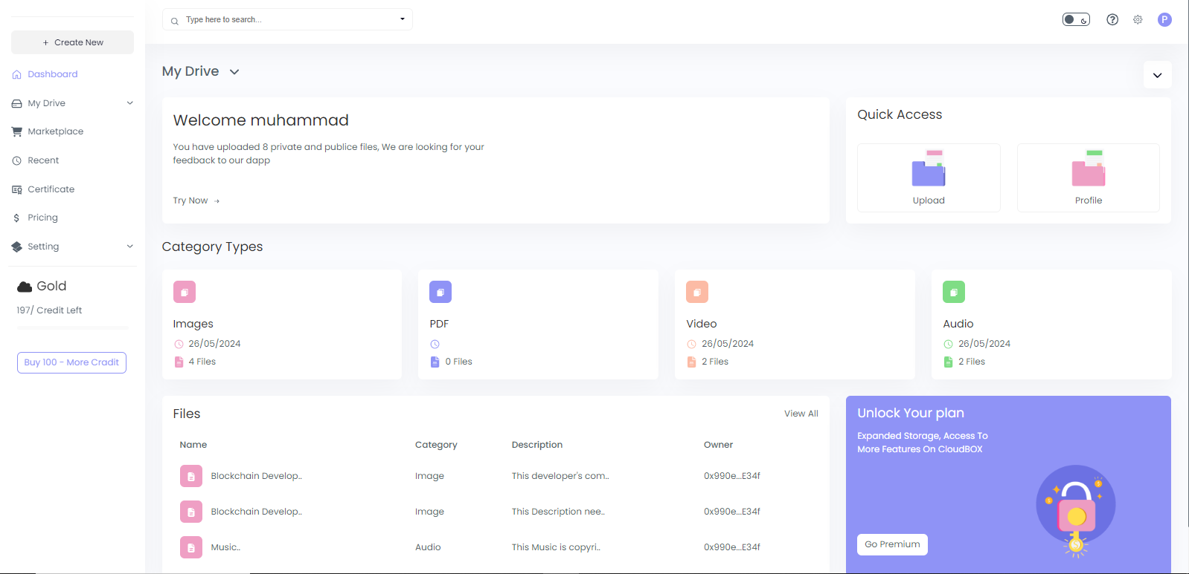
Figure 4.3 Dashboard

4.4 Login
The user authentication interface for secure access is designed to be both robust and user-friendly, ensuring only authorized users can access the system.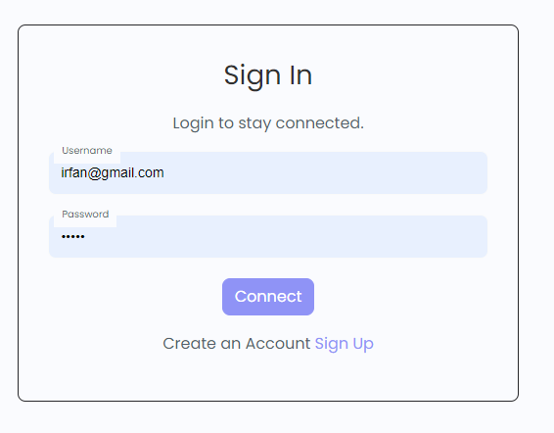
Figure 4.4 Login

4.5 Sign Up
The registration form for new users to create accounts is straightforward and easy to use, guiding users through essential information fields.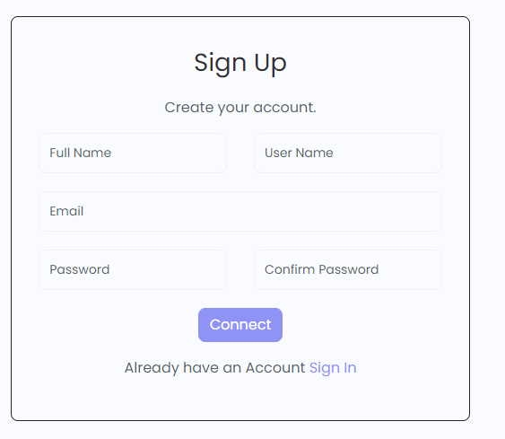
Figure 4.5 Sign Up

4.6 Upload
The functionality for users to upload files to the system is seamless and efficient, ensuring quick and secure file transfers.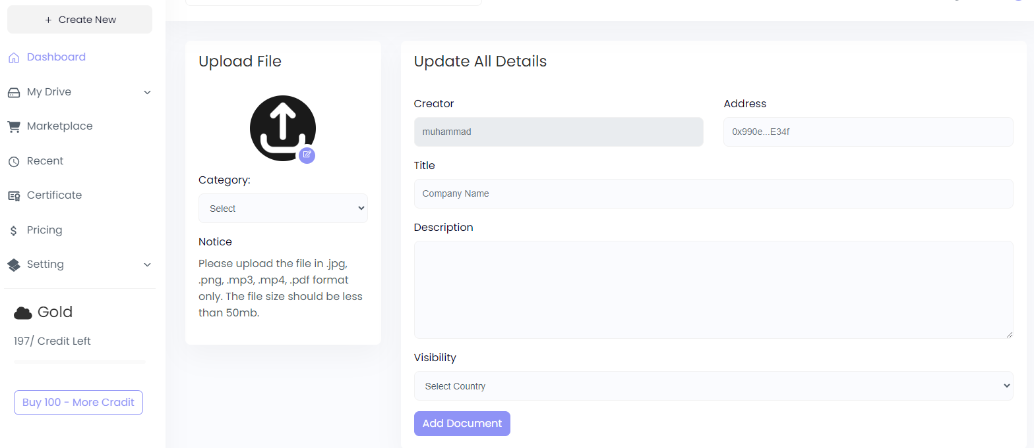
Figure 4.6 Upload

4.7 Update User
The feature allowing users to update their personal information is intuitive, enabling easy and secure modifications to user profiles.
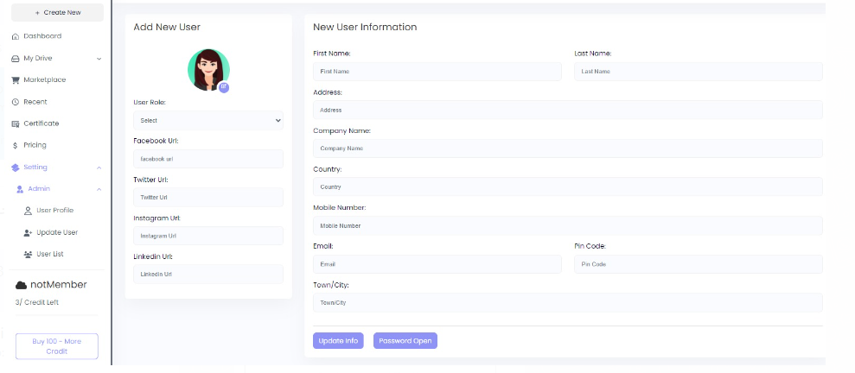
Figure 4.7 Update User

4.8 Side Bar
The navigational menu for easy access to different sections.

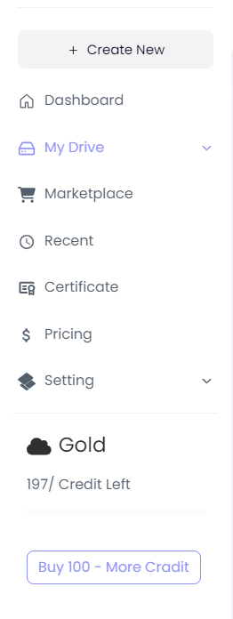
Figure 4.8 Side Bar

4.9 Buy
The interface for purchasing additional services or features is user-friendly, facilitating quick and secure transactions. 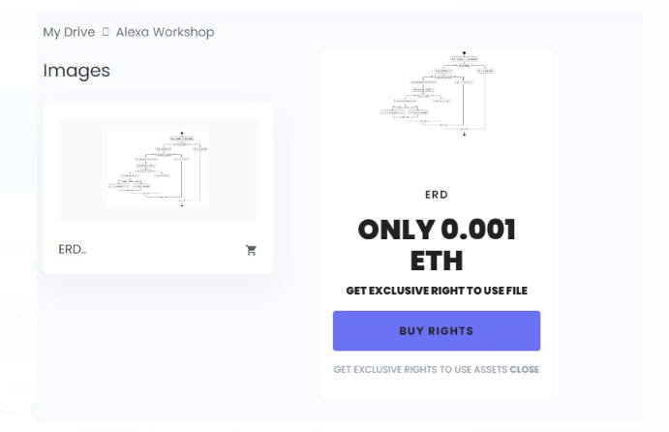
Figure 4.9 Buy

4.10 Marketplace
The section where users can access and share files with others provides seamless collaboration.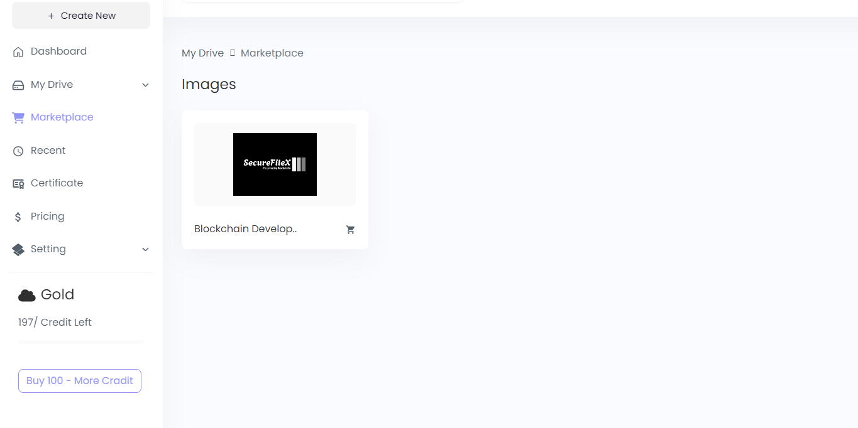Figure 4.10 Marketplace

4.11 Premium Plan:
The options for users to upgrade to premium services are clearly presented, offering enhanced functionalities and benefits.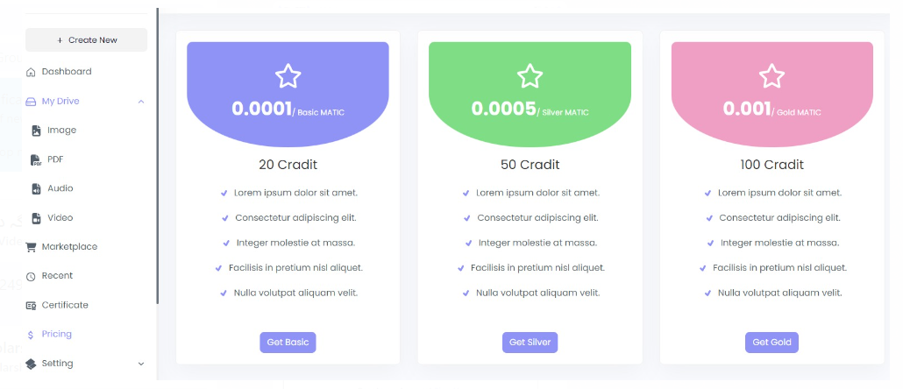
Figure 4.11 Premium Plan

CHAPTER 5

ARCHITECTURE AND DESIGN

5.1 Introduction
In today's digital landscape, the necessity for secure and efficient file-sharing systems has reached paramount importance. Conventional methods often grapple with issues such as centralized control, data security vulnerabilities, and privacy concerns. Introducing a blockchain-based file-sharing system, this chapter explores a transformative approach to addressing these challenges. The forthcoming sections delve into the architecture and design principles that underlie this innovative file-sharing system, providing insights into its structure, components, and functionality.
Built on the foundational principles of security, transparency, and user control, the system aims to furnish users with a platform for secure file-sharing while empowering them with greater data autonomy. By leveraging blockchain technology, it circumvents the need for centralized intermediaries, mitigating the risks associated with data breaches and unauthorized access. The architecture is envisaged as modular, scalable, and interoperable, facilitating seamless integration with existing systems and technologies. Key components include the user interface, backend infrastructure, blockchain network, and decentralized storage solutions. Each component contributes significantly to ensuring security, efficiency, and user experience. [10]
The user interface provides an intuitive platform for accessing and managing files. Through it, users can upload files, set access permissions, and track transaction history, enhancing visibility and control over their data. Designed to be responsive and accessible, it ensures a seamless experience across various devices. The backend infrastructure processes user requests, manages file storage and encryption, and interfaces with the blockchain network. Comprising servers and databases, it is engineered for scalability and resilience, adept at handling vast data volumes and user interactions. The blockchain network serves as a distributed ledger, recording file transactions securely and transparently. Users leverage this network to share files securely, set access permissions, and track transaction history. Powered by a consensus mechanism, it guarantees network integrity and security. Decentralized storage solutions, like IPFS (InterPlanetary File System), store files off-chain while maintaining references on the blockchain.

5.2 System Overview
The SecureFileX system is designed to revolutionize file sharing by leveraging blockchain technology to provide a secure, transparent, and decentralized platform. At its core, SecureFileX enables users to securely upload, share, and manage files while maintaining control over their data. The system comprises several key components, including. [10]

5.2.1 User Interface
The front-end interface provides users with intuitive access to SecureFileX's functionalities, allowing them to upload files, manage permissions, and view transaction history seamlessly.

5.2.2 Backend Infrastructure
The backend infrastructure encompasses the server-side components responsible for processing user requests, managing file storage and encryption, and interfacing with the blockchain network.

5.2.3 Blockchain Network
SecureFileX utilizes a blockchain network, such as Ethereum or Hyperledger, to record file transactions and ensure data integrity. Smart contracts govern file access and permissions, enabling transparent and secure file sharing.[7]

5.2.4 Decentralized Storage
Files uploaded to SecureFileX are securely stored using decentralized storage solutions like IPFS (InterPlanetary File System). This distributed storage approach enhances data resilience and availability while mitigating the risks associated with centralized storage.

5.3 Blockchain Architecture
The blockchain architecture of SecureFileX is designed to ensure the security, transparency, and immutability of file transactions. By leveraging blockchain technology, SecureFileX eliminates the need for a central authority, reducing the risk of data breaches and unauthorized access. The architecture comprises the following components:

5.4 File Storage and Management
File storage and management are fundamental aspects of the blockchain-based file sharing system, ensuring the secure and efficient handling of user data. This section explores the mechanisms employed for file storage and management within the system. The system utilizes decentralized storage solutions, such as IPFS (InterPlanetary File System), to store files securely off-chain while maintaining references on the blockchain. This approach offers several advantages, including enhanced data resilience, availability, and security. By distributing file storage across a network of nodes, the system mitigates the risks associated with centralized storage systems, such as single points of failure and data breaches. Files uploaded to the system undergo encryption before being stored on the decentralized storage network. This encryption ensures that files remain confidential and tamper-proof, protecting them from unauthorized access and manipulation. Users retain control over their encryption keys, ensuring that only authorized parties can decrypt and access their files. [11]

5.5 Context Diagram
The Context Diagram, often referred to as Level 0 DFD, offers a high-level overview of the system's boundaries and its interactions with external entities. This diagram presents the system as a single process or entity, depicted as a square or rectangle in the center. External entities, represented by circles or ovals, surround the system, interacting with it without being part of it. Arrows indicate the flow of data between the system and these external entities, illustrating inputs to and outputs from the system.
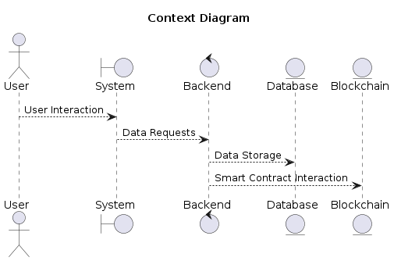
Figure 5.5 Context Diagram

5.6 Entity Relationship Diagram {ERD}
The Entity-Relationship Diagram (ERD) provides a visual representation of the relationships between different entities in the "SecureFileX: Blockchain-based File Sharing System" project.
In the ERD:
    - User:
Represents individuals who use the system. Each user has a unique ID, username, email, password hash for security, and registration date.
    - File:
Represents the files uploaded and shared within the system. Each file has a unique ID, name, size, type, and upload date.
    - Access Control:
Represents access control entries that specify permissions granted to users for accessing files. Each access control entry links a user to a file and includes permission details.
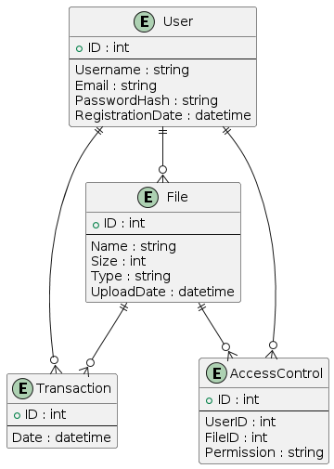
Figure 5.6 Entity Relationship Diagram {ERD}

5.7 Level 0 DFD
The Level 0 DFD, also known as the context diagram, provides an overview of the entire system by showing how it interacts with external entities. It depicts the system as a single process or entity and highlights the external entities that interact with it. This diagram does not provide detailed information about internal processes but rather focuses on the system's boundaries and external interactions.
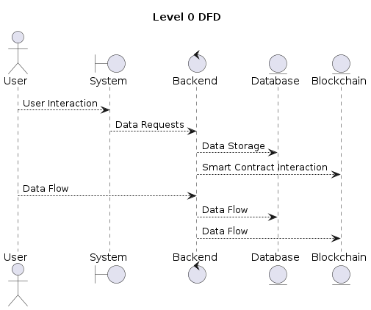
Figure 5.7 Level 0 DFD

Level 1 DFD
The Level 1 DFD expands on the context diagram by breaking down the system into its main subprocesses or modules. It represents the top-level processes or subsystems within the system and their interactions. This diagram provides a more detailed view of the system's functionality compared to the context diagram while still maintaining a high-level overview.
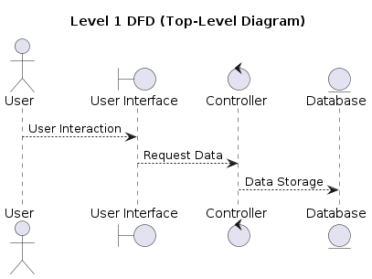
Figure 5.8 Level 1 DFD

5.9 Level 2 DFD
The Level 2 DFD further elaborates on the processes identified in the Level 1 DFD by breaking them down into smaller subprocesses or activities. It provides a detailed view of the internal workings of the system, showing the flow of data between individual processes or components. This diagram may include additional details such as data stores, data flows, and data transformations within each subprocess.
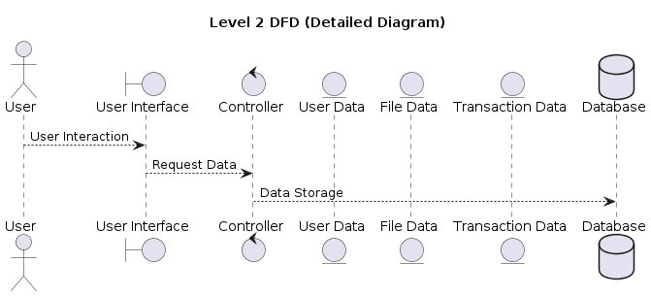
Figure 5.9 Level 2 DFD

5.10 System Workflow
The system workflow of our blockchain-based file sharing system is meticulously designed to streamline user interactions and ensure seamless operations. Upon uploading a file, users authenticate their identity and specify access permissions. Smart contracts deployed on the blockchain enforce these permissions autonomously, automating the process of granting or revoking access to files. Users can track the history of file transactions through transparent and auditable logs, providing visibility into the flow of data within the system. This streamlined workflow enhances user experience and promotes trust in the system's operations.

5.11 Scalability and Performance Considerations
Scalability and performance are key considerations in the design of our blockchain-based file sharing system. As the volume of data and user interactions grows, the system must be capable of accommodating increased demand without sacrificing performance. To achieve scalability, we employ distributed architectures and parallel processing techniques, allowing the system to scale horizontally by adding additional nodes or resources. Additionally, performance optimizations, such as caching and load balancing, are implemented to ensure efficient resource utilization and minimize latency. By prioritizing scalability and performance, our system can effectively meet the evolving needs of users and sustain high levels of service quality. [12]

5.12 Integration with Existing Systems
Seamless integration with existing systems is essential for the adoption and success of our blockchain-based file sharing system. We recognize the importance of interoperability and compatibility with a diverse range of platforms and technologies. To facilitate integration, we offer comprehensive APIs and interoperability standards that enable seamless data exchange and communication between our system and external systems. Additionally, we provide support for industry-standard protocols and data formats, ensuring compatibility with existing infrastructures and workflows. By offering robust integration capabilities, our system can seamlessly complement and enhance existing systems, facilitating a smooth transition to blockchain-based file sharing.

CHAPTER 6

IMPLEMENTATION

6.1 Frontend Implementation
In the frontend implementation of our blockchain-based file sharing system, we focus on creating a user-friendly and visually appealing interface that facilitates seamless interaction with the system's features and functionalities. This section provides an in-depth overview of the frontend technologies, code structure, and key features employed in the implementation. [13]

6.1.1 Frameworks and Libraries
In the frontend implementation of our blockchain-based file sharing system, we leverage several frameworks and libraries to ensure a robust and intuitive user interface.

6.1.2 React.js:
This JavaScript library is utilized for building dynamic and interactive user interfaces. Its component-based architecture allows for the creation of reusable UI components, promoting code efficiency and maintainability.

6.1.3 Next.js:
We employ Next.js for server-side rendering and static site generation, enhancing performance and SEO optimization. Next.js offers seamless integration with React.js and simplifies the development of complex web applications.

6.1.4 HTML2Canvas:
To capture web pages as images, we integrate HTML2Canvas into our frontend implementation. This library enables users to generate screenshots of files and documents, facilitating easy sharing and visualization.

6.1.5 jsPDF:
For generating PDF documents from web content, we utilize jsPDF. This library offers comprehensive functionalities for creating, manipulating, and rendering PDFs directly from the browser, ensuring compatibility and ease of use.

6.1.6 Code Structure
Our frontend codebase is organized into distinct modules and follows a structured approach to development.

6.1.7 Components:
We adopt a modular and reusable approach to UI development, encapsulating common UI elements into individual components. This modular design promotes code reusability and facilitates maintenance and scalability.

6.1.8 Pages:
Next.js provides page-based routing for different views within the application. Each page corresponds to a specific route and encapsulates the logic and UI components associated with that route, enhancing code organization and navigation.

6.1.9 Styles:
We utilize CSS and styled-components for styling our frontend components. CSS provides a powerful styling mechanism, while styled-components offer a convenient way to encapsulate styles within individual components, enhancing modularity and maintainability.

6.2 Key Features
Our frontend implementation incorporates several key features to enhance user experience and functionality.

6.2.1 User Authentication:
We prioritize secure login and registration processes, implementing robust authentication mechanisms to protect user accounts and sensitive data.

6.2.2 Dynamic Content:
Our frontend dynamically renders content based on user interactions, providing a seamless and responsive user experience.

6.2.3 PDF Generation:
Users can generate downloadable PDF documents directly from web content, facilitating easy sharing and distribution of files and documents.

6.3 Backend Implementation
We used the following libraries and frameworks for better management of backend implementation.

6.3.1 Frameworks and Libraries
In the backend implementation of our blockchain-based file sharing system, we rely on a range of frameworks and libraries to facilitate server-side operations and backend logic.

6.3.2 Node.js:
As a JavaScript runtime environment, Node.js enables us to build scalable and efficient server-side applications. Its event-driven architecture and non-blocking I/O operations ensure optimal performance and responsiveness.

6.3.3 bcryptjs:
For secure user authentication, we employ bcryptjs for password hashing. This library offers robust encryption algorithms to safeguard user credentials and prevent unauthorized access.

6.3.4 axios:
We use axios for handling HTTP requests to external APIs and services. Its promise-based API and built-in support for interceptors simplify the process of making asynchronous requests and handling responses.

6.3.5 ethers.js:
To interact with the Ethereum blockchain, we integrate ethers.js into our backend implementation. This library provides a comprehensive set of tools and utilities for working with Ethereum smart contracts and blockchain data, enabling seamless integration with our file sharing system.

6.4 Code Structure
Our backend codebase follows a structured and modular approach to development, with distinct components responsible for handling different aspects of the application.

6.4.1 Controllers:
Controllers encapsulate request handling logic and business logic, ensuring separation of concerns and promoting code organization and readability.

6.4.2 Routes:
We define API endpoints using routes, mapping incoming requests to corresponding controller functions. This modular approach to routing facilitates scalability and maintainability, allowing us to easily add or modify API endpoints as needed.

6.4.3 Models:
Models define data structures and schemas, providing a logical representation of the application's data. By defining clear data models, we ensure consistency and integrity in data management operations. Our backend implementation incorporates several key features to support the functionality and operation of our file sharing system.

6.4.4 API Endpoints:
We expose RESTful APIs for frontend communication, allowing seamless interaction between the frontend and backend components of the application.

6.4.5 Blockchain Interaction:
Our backend interacts with smart contracts deployed on the Ethereum blockchain, facilitating secure and transparent file transactions and data management.

6.4.6 Data Management:
We ensure secure storage and retrieval of user data, implementing robust data management practices to protect sensitive information and maintain data integrity.

6.5 Blockchain Implementation
In the blockchain implementation of our file sharing system, we leverage Solidity for writing smart contracts that govern file transactions on the Ethereum blockchain. [14]

Solidity:
We utilize Solidity for writing smart contracts that define the rules and conditions for file transactions on the Ethereum blockchain. Solidity is specifically designed for blockchain development and allows us to create secure.
6.5.2 Web3Modal:
Web3Modal is integrated into our system to facilitate wallet integration for users. It connects to various wallet providers like MetaMask, allowing users to interact with their crypto wallets.

Key Features:
- User authentication and management with Metamask, including user profile display.
- File handling and storage on IPFS, which support various file types like images, videos, audio, and PDFs.
- A marketplace for listing and purchasing exclusive rights to files, with Polygon (MATIC).
- Secure handling of user data and transactions with blockchain technology.

6.6 Storage Implementation
Our storage implementation focuses on decentralized storage solutions, leveraging IPFS for storing files in a decentralized manner. Additionally, we utilize Pinata as a service provider to facilitate IPFS storage via API for easier management. [14]
6.6.1 IPFS:
We store files in a decentralized manner using IPFS, a distributed file system that provides a high-performance and resilient storage solution. IPFS allows files to be stored across multiple nodes in a peer-to-peer network, ensuring redundancy and availability.
6.6.2 Pinata:
Pinata is integrated into our system to facilitate IPFS storage via API. Pinata offers a range of features and tools for managing files on IPFS, including pinning services, file encryption, and metadata management.
    - File Upload:
Users can upload files to IPFS directly from the application, leveraging the decentralized storage capabilities of the IPFS network.
    - File Retrieval:
Our system enables users to access and retrieve files from IPFS, ensuring seamless access to stored data across different devices and platforms.

6.7 Build and Deployment
Our build and deployment process is streamlined using npm as the package manager for managing project dependencies and scripts. Automated build scripts are employed for building the application, and deployment tools such as Vercel for Next.js and Heroku for Node.js are utilized for deploying the application to production environments.

6.8 Programming Languages
In our implementation, JavaScript serves as the primary language for both frontend and backend development. Additionally, Solidity is used for blockchain smart contract development, enabling the creation of secure and efficient contracts that govern file transactions on the Ethereum blockchain.

CHAPTER 7

TESTING AND EVALUATION

7.1 Introduction
In the intricate landscape of software development, testing emerges as a pivotal phase ensuring the robustness, security, and effectiveness of systems. Within the domain of the "SecureFileX: Blockchain-based File Sharing System" project, testing assumes a critical role. This section serves as a gateway to understanding the comprehensive testing procedures integrated into the project's framework. Testing serves as an indispensable tool in the software development lifecycle, acting as a shield against potential vulnerabilities and ensuring that the final product meets stringent quality standards. In the context of the "SecureFileX" project, rigorous testing protocols are implemented to validate the reliability, security, and functionality of the file-sharing system.
The significance of testing cannot be overstated, particularly in systems dealing with sensitive data and employing cutting-edge technologies like blockchain. By subjecting the system to various testing methodologies, including unit testing, integration testing, system testing, and acceptance testing, the project team endeavors to identify and rectify any anomalies or deficiencies in the software. [15]

7.2.1 Unit Testing
Unit testing involves testing individual components or units of the system in isolation to ensure they function as expected. This section discusses the objectives, methods, and tools used for conducting unit tests.
Table 7.2 Unit Testing
No. | Test Case/Test Script | Attribute and Value | Expected Result | Result
1 | Authentication | Valid credentials | Successful login | Pass
2 | File Upload | Valid file | File uploaded | Pass
3 | Encryption | File encryption | Data secured | Pass

7.2.2 Integration Testing
Integration testing focuses on testing the interactions between different modules or components of the system to verify that they work together seamlessly. This section explains the integration testing process and the strategies employed to identify and address integration issues.
Table 7.3 Integration Testing
No. | Test Case/Test Script | Attribute and Value | Expected Result | Result
1 | User Interface | Interaction flow | Seamless navigation | Pass
2 | Database Integration | Data retrieval | Accurate data retrieval | Pass
3 | Blockchain Integration | Smart contract interaction | Successful transactions | Pass

7.2.3 System Testing
System testing evaluates the system as a whole to validate its compliance with specified requirements and assess its overall performance and functionality. This section describes the system testing approach and the techniques used to assess system behavior under various conditions.
Table 7.4 System Testing:
No. | Test Case/Test Script | Attribute and Value | Expected Result | Result
1 | Performance | System load | Stable performance | Pass
2 | Security | Data encryption | Protected data | Pass
3 | Compatibility | Cross-browser compatibility | Consistent user experience | Pass

7.2.4 Process of Test Plan
The process of creating a test plan involves defining the scope, objectives, resources, and timelines for testing activities. This section outlines the steps involved in developing a comprehensive test plan tailored to the requirements of the "SecureFileX" project.

7.2.5 Acceptance Testing
Acceptance testing involves validating the system against user-defined criteria to ensure it meets business requirements and user expectations. This section discusses the acceptance testing process and the criteria used to determine whether the system is ready for deployment.
Table 7.5 Acceptance Testing:
No. | Test Case/Test Script | Attribute and Value | Expected Result | Result
1 | Usability | User interface | Intuitive design | Pass
2 | Functionality | Core features | Functionality as expected | Pass
3 | Performance | System responsiveness | Smooth performance | Pass

7.3 Testing Introduction
This section provides a detailed introduction to the testing methodology adopted in the "SecureFileX" project, emphasizing the importance of testing in achieving a high-quality, reliable software product.
Table 7.6 Testing Introduction
No. | Test Case/Test Script | Attribute and Value | Expected Result | Result
1 | Authentication | Valid credentials | Successful login | Pass
2 | File Upload | Valid file | File uploaded | Pass
3 | Encryption | File encryption | Data secured | Pass

7.4 Implications for Data Governance
The "SecureFileX" project extends beyond its immediate utility as a file sharing platform, carrying profound implications for the future of data governance and decentralized technologies. By embracing blockchain principles, the project pioneers a paradigm shift towards privacy-preserving technologies and user-centric data management practices. Through immutable transaction records and decentralized storage solutions, "SecureFileX" empowers users with greater control over their data while fostering trust in digital interactions. This innovative approach not only enhances data security and integrity but also challenges traditional models of centralized data control, paving the way for a more transparent and equitable data governance landscape. [15]

7.5 Integration with Existing Systems
The seamless integration of the "SecureFileX" platform with existing file sharing protocols and systems underscores its commitment to interoperability and user convenience. By leveraging open standards and APIs, "SecureFileX" facilitates frictionless data exchange across diverse platforms, ensuring compatibility with a wide range of existing systems. Whether integrating with cloud storage providers, collaboration tools, or enterprise solutions, "SecureFileX" bridges the gap between decentralized technologies and established infrastructures, thereby enhancing its accessibility and adoption across diverse user environments.

7.6 User Experience Design
At the heart of the "SecureFileX" project lies a relentless focus on user experience design, aimed at delivering intuitive interfaces and seamless file management workflows. By prioritizing user-centric design principles, such as simplicity, consistency, and accessibility, "SecureFileX" enhances usability and satisfaction for users of all skill levels. From effortless file uploads to granular access controls, every aspect of the platform is meticulously crafted to optimize user engagement and productivity. Through continuous iteration and feedback-driven refinement, "SecureFileX" ensures that its design remains aligned with user needs and preferences, fostering a positive and engaging user experience.

CHAPTER 8

CONCLUSION

8.1 Recapitulation of Objectives
Throughout the project’s development, our primary aim has been to disrupt traditional file sharing paradigms by harnessing the potential of blockchain technology. We endeavored to establish a secure, transparent, and decentralized platform for file sharing and management, addressing the challenges of centralized control, data security, and user privacy.

8.2 Achievements and Milestones
During the project lifecycle, significant progress has been achieved in realizing our objectives. We successfully architected and implemented a robust file sharing system powered by blockchain, ensuring data integrity, security, and user autonomy. Moreover, our platform seamlessly integrates with existing systems, demonstrating its versatility and compatibility across diverse environments.

8.3 Impact and Implications
The “SecureFileX” project holds profound implications for the future of decentralized technologies and data governance. By advocating for privacy-preserving technologies and user-centric data management practices, we contribute to discussions on digital sovereignty and trust in the digital era. Our platform empowers users with control over their data, fostering transparency and accountability in digital transactions.

8.4 Future Directions
Looking ahead, we envision exciting prospects for the “SecureFileX” platform. We are committed to enhancing its functionality, scalability, and accessibility to meet evolving user demands. Our dedication to continuous innovation and improvement will drive exploration of new avenues for collaboration, integration, and technological advancement.

8.5 Gratitude and Acknowledgments
We express sincere gratitude to all individuals and organizations who contributed to the success of the “SecureFileX” project. Their unwavering dedication, expertise, and support have been instrumental in realizing our vision and bringing the project to fruition.

REFERENCE

[1] Nakamoto, S. (2008). Bitcoin: A Peer-to-Peer Electronic Cash System. Available at: https://bitcoin.org/bitcoin.pdf
[2] Wood, G. (2014). Ethereum: A Secure Decentralized Generalized Transaction Ledger. Ethereum Project Yellow Paper.
[3] Ali, M., Nelson, J., Shea, R., & Freedman, M. J. (2016). Blockstack: A Global Naming and Storage System Secured by Blockchains. In 2016 USENIX Annual Technical Conference (USENIX ATC 16) (pp. 181-194).
[4] Zyskind, G., Nathan, O., & Pentland, A. (2015). Decentralizing Privacy: Using Blockchain to Protect Personal Data. In 2015 IEEE Security and Privacy Workshops (pp. 180-184).
[5] Benet, J. (2014). IPFS - Content Addressed, Versioned, P2P File System (DRAFT 3). Available at: https://ipfs.io/ipfs/QmR7GSQM93Cx5eAg6a6b2x4F4wAnJBBTf1peVGk9dAaaG6
[6] Crosby, M., Pattanayak, P., Verma, S., & Kalyanaraman, V. (2016). Blockchain technology: Beyond bitcoin. Applied Innovation Review, 2, 6-19.
[7] Christidis, K., & Devetsikiotis, M. (2016). Blockchains and Smart Contracts for the Internet of Things. IEEE Access, 4, 2292-2303.
[8] Swanson, T. (2015). Consensus-as-a-service: a brief report on the emergence of permissioned, distributed ledger systems. Available at: https://allquantor.at/blockchainbib/pdf/swanson2015.pdf
[9] Zhang, Y., Kasahara, S., Shen, Y., Jiang, X., & Wan, J. (2018). Smart Contract-Based Access Control for the Internet of Things. IEEE Internet of Things Journal, 6(2), 1594-1605.
[10] Mattila, J. (2016). The Blockchain Phenomenon - The Disruptive Potential of Distributed Consensus Architectures. The Research Institute of the Finnish Economy. Available at: https://www.etla.fi/wp-content/uploads/ETLA-Raportit-Studies-42.pdf
[11] Mettler, M. (2016). Blockchain technology in healthcare: The revolution starts here. In 2016 IEEE 18th International Conference on e-Health Networking, Applications and Services (Healthcom) (pp. 1-3).
[12] McConaghy, T., Marques, R., Müller, A., De Jonghe, D., McConaghy, T., McMullen, G., ... & McConaghy, V. (2017). BigchainDB: A Scalable Blockchain Database. Available at: https://www.bigchaindb.com/whitepaper/bigchaindb-whitepaper.pdf
[13] Xu, X., Weber, I., & Staples, M. (2019). Architecture for Blockchain Applications. Springer.
[14] Garay, J., Kiayias, A., & Leonardos, N. (2015). The Bitcoin Backbone Protocol: Analysis and Applications. In Annual International Conference on the Theory and Applications of Cryptographic Techniques (pp. 281-310). Springer, Berlin, Heidelberg.
[15] Rouhani, S., & Deters, R. (2017). Security, Performance, and Applications of Smart Contracts: A Systematic Survey. IEEE Access, 7, 50759-50779.

